FACULTY PROFILE

Name : Dr. Anil Sitaram Jagtap
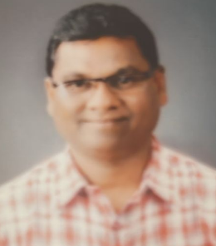
Qualification : M. A., Ph.D.
Department : History
Designation : Assistant Professor
Email : aniljagtap0106@gmail.com
Teaching Experience : UG. 31 years PG - 08
ACADEMIC CONTRIBUTIONS
Research Papers: 43
Books: 07
Work in Editorial Board: 02
Research Area- Ancient, Medieval and Modern Indian History
AWARDS/ FELLOWSHIP:
Social and Research Contribution: 06

